P.2
RELIGIOUS EDUCATION

NOTES FOR TERM TWO 2016

THEME: CHRISTIANS LIVING TOGETHER IN GOD’S FAMILY

Learning outcome5: The child understands the death and resurrection of Jesus and appreciates his love and joy of resurrection.
Lesson one
Sub- theme: Knowing Jesus’ love for us

Telling the events of the last supper that Jesus had with his disciples
-Jesus sat on the same table with his disciples
-He shared a meal with them.
-He took a cup of wine and gave thanks to God then he gave his disciples to drink. (Symbolizing Jesus’ blood)
-He shared bread with his disciples. (Symbolizing Jesus’ body)
Bible reading, Luke 22:7-20
Lesson two
Jesus’ disciples

Judas Iscariot
Simon Peter
John
Matthew
Andrew
Bartholomew
Philip of Bethsaida
Thomas
Thaddaeus- Judas
Simon the Zealot
James son of Zebedee
James son of Alphaeus

Colour and write down what is happening in the picture.
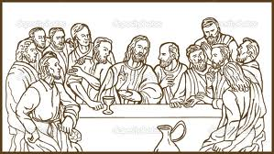
Disciples of Jesus
How Jesus showed love and care to people
-God wants us to love one another as he loved us.
- Jesus died for our sins on the cross.
-Fed the hungry
- He healed the sick
- Etc
Lesson four and five

What happened before and during Jesus’ death [events?]

Jesus went through the following.
-He was betrayed by Judas Iscariot.
-He was arrested and beaten.
- He was stripped naked.
-He was forced to carry a big cross.
-He was crowned with a crown of thorns.
-He fell down three times with the big cross.
-He was nailed unto the cross.
- He was given bitter wine while on the cross.
-He finally died on the cross. Pentagram bk2 pg 36-38

Name the events Jesus went through before the crucification on the cross.
 | 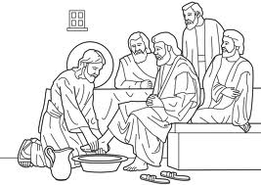 | 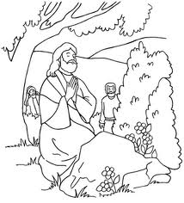 | 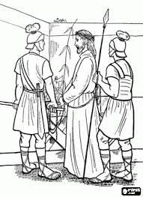 | 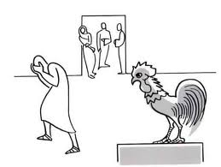 | 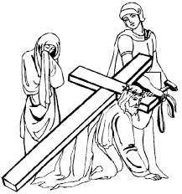 | 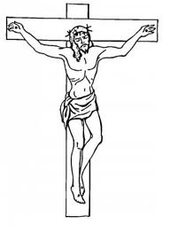

-He was carried into the tomb by Joseph of Arimethea.
-Joseph placed a very big stone unto the entry of the tomb.

Lesson six
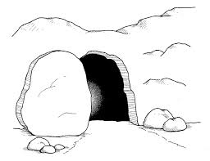 | 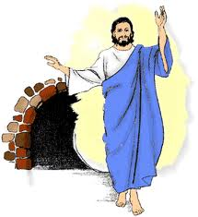 | 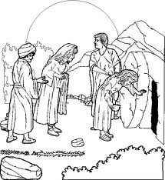 | 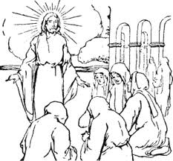
Jesus’ tomb | Risen Jesus | Empty tomb | Jesus appears to the disciples

Things which happened on the resurrection of Jesus.
Resurrection means to come to life after death.

-Mary Magdalene went to the tomb to pour perfume unto the body of Jesus.
- She found the tomb open.
- Jesus had resurrected.
-She ran to the colleagues and informed them
- He over came death.
-He rose from the dead.
-He appeared to his apostles.
-He lives with us today.
-That’s why Christians celebrate Eater Sunday.
Pentagram bk2 page 40-41

Learning outcome6: The child knows the Christian ways of worshipping and appreciates God at home, school and church.

Lesson seven
Sub-theme: Worshipping God.
To worship God means to put God at the top of everything. Exodus 20:3

Why do we worship God .

-To thank Him.
-To ask for forgiveness.
- To praise Him.
-To ask for protection, riches, wisdom etc
-To tell him about our problems.

Pentagram bk2 page 43-47

Ways of worshipping God.

[How can we worship God?]
-By praying.
-By singing.
-By reading the Bible.
-By listening to the preachers.
-By listening to gospel music.
- Offering to God.

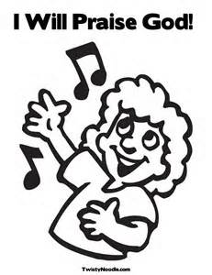 | 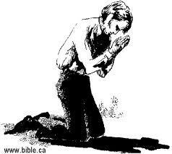 | 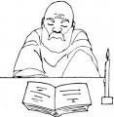 | 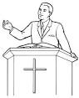 | 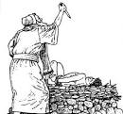
Praising in a song | Praying | Read the word | Preaching the word | Abraham Offering the son

Lesson eight
Where can we worship God from?
God can be worshipped from anywhere anytime but there some areas designed to worship God from like;

- The church
- The temples
- The synagogues
Other places can be;
- The home
- The vehicles
- The open places like our school field.
- The kitchen
- The garden
- E.t.c

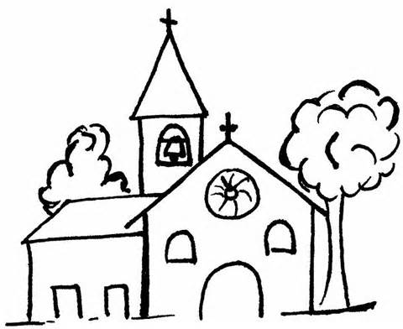 |  | 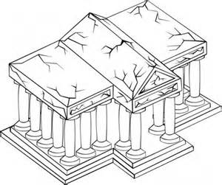
Church | Temple | temple
Pentagram bk2 page 46-47

Occasions for prayers

-Before and after.
-Before and after the journe

- During times of joy e.g. birthday, baptism, dedication, introduction, wedding, graduation, e.t.c.
-During times of sorrow e.g. sickness and death.

-Before and after sleeping.
-E.t.c

Draw yourself worshipping

Lesson nine
Pentecost
Pentecost is the day when the Holy Spirit came down to the disciples in the upper room.
The Holy Spirit is the third person in the Holy Trinity.
- Before Jesus went to heaven after resurrection.
- He promised to send us a helper.
- The helper is the Holy Spirit.
- Forty days after Easter the disciples received the Holy Spirit.
- Pentagram bk2 pages 50-51
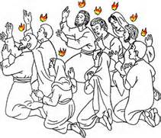
Pentecost day
Lesson ten
What did the disciples get from the Holy Spirit?
- They started performing miracles.
- They spoke in different languages.
- They healed the sick.
- They got confidence to speak about God.

NB; Even today the Holy Spirit helps Christians.
- It helps us to worship God.
- It helps us to pray.
- It helps us to know what is good and bad.
- It helps to understand the word of God.
- It helps us to be obedient, self-controlled, kind, patient, and e.t.c.
- It helps us to overcome challenges.

Learning outcome7: the child understands the importance of serving others, is ready to persevere and looks for ways of serving.

Lesson eleven
Sub-theme: Service
Needs are things people need in order to live healthily and safe.

Types of needs

- Luxury needs
- Basic needs

Luxury needs are the needs that man can go without e.g. a television
Basic needs are those that man can not do without.

Needs of people
Medical care
Shelter
Clothes
Security
Food
Water
Transport
Education
Money

Pentagram bk2 pages 52-53
Draw and name three needs of people.
 | 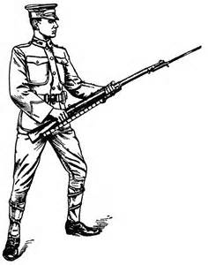 | 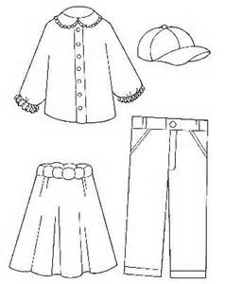 |  | 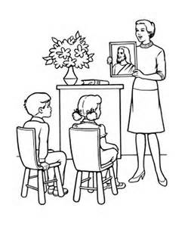
Shelter | Security | Clothes | Transport | Education
Discovering the needs of people
How do we discover the needs of people?

- by asking them
- by visiting them
- by observing them as they move
- by debating on the problems of different areas

Pentagram bk2 pages 54-55
Draw and name four things people need in your area
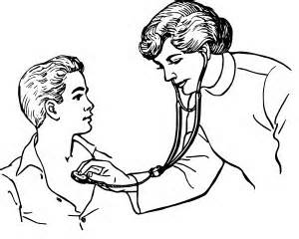  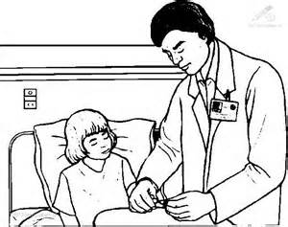 | 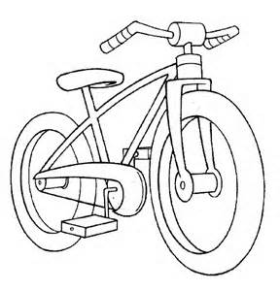  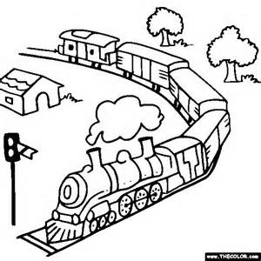 | 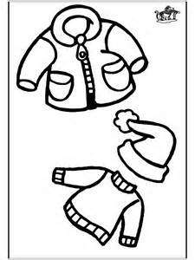 | 
Treatment | Transport | Clothes | Water

Lesson twelve
How did Jesus show His Kindness?

- Jesus was kind to all people
- He helped people in many different ways
- He made the lame to walk
- He made the deaf to hear.
- He made the blind see.
- He made the dumb talk
- He fed the hungry [500 people]
- He died for our sins on the cross
- He loved the children
- He forgave people the bad things they did to others.
- He rose from the dead

Bible reading
How Jesus showed his kindness
Jesus’ visit to Mary and Martha [Luke 11: 38-41]
Jesus’ raises Lazarus from the dead. [John 11: 17-44]

Lesson thirteen
Caring for the people with special needs
Helping people with disabilities

- washing for them
- cooking for them
- feeding them
- encouraging them
- taking them to health centers
- speak for them (those who can’t speak)
- e.t.c

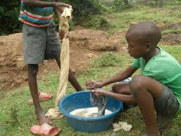
Washing for them
Some people have these problems

- Some can not see
- Some can not hear
- Some can not walk
- Some can not talk
- Some can not hold
- Some can not think well
- Some can not stand/sit

People with such problems are called disabled. They need our support, care, love and attention.
Draw Simon Peter and John heal a disabled person.
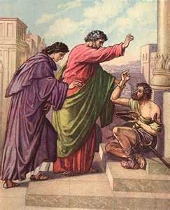

Learning outcome8: The child is able to understand the importance of serving others; is ready to persevere and looks for ways of serving.

Lesson fourteen

Difficulties Jesus met when healing the sick. [Matt 12: 9-14]
- Some people did not thank him.
- Some other people were teasing him.
- Some others did not believe that Jesus had the power to heal them.
- Some people did not want to see Jesus healing the sick.
- Some other wanted to kill him instead.
Pentagram bk2 pages 60-61
Ways in which we have helped others

- Sharing with them
- Directing them
- Showing love
- Showing empathy
- Encouraging them
- Praying for them

Problems we face while helping others

- Some people are not thankful.
- Some people do not want the help.
- Some people take the helper unserious.
- Some times we get accidents as we serve others
- Etc

What we do when discouraged as we help others

- Never give up.
- Forgive those who discourage.
- Pray for them.
- Reflect on the goodness of helping others.

Lesson fifteen

Mention five ways in which we have helped others

